Grade 7 Accelerated · Unit 4 · Lessons 7–8  Real-World Order of Operations  Question Bank 4.07 ANSWER KEY | Name  Date  Period

Show your work. Circle your final answer.
For questions 1 through 4, substitute and evaluate.
1. 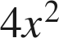 when 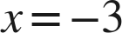
36
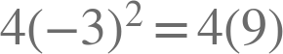.

2.  when  and 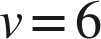
900
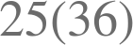.

3. 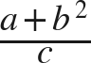 when 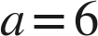, 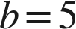, 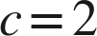

The bar groups the whole numerator: 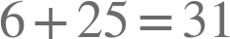.

4. 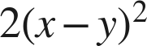 when 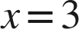 and 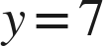
32
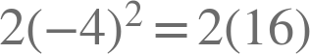.

For questions 5 and 6, write and evaluate an expression. Give the unit.
5. A square room of side 11 feet is floored at 3.20 dollars a square foot, with a flat 75 dollars for delivery. Find the total cost.
 dollars
The rate is per square foot, so it multiplies the area; the delivery is flat, so it does not.

6. A rectangular deck 14 feet by 9 feet is stained at 1.15 dollars a square foot, with a flat 48 dollars for equipment hire. Find the total cost.
dollars
The area is 126 square feet.

Two formulas.
7. Body mass index is 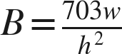, where is a weight in pounds and is a height in inches. Find  to the nearest tenth.
a. , 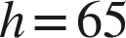
25.0
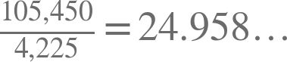
b. , 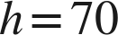
25.8
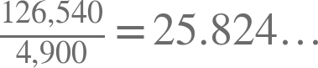
c. , 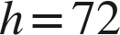
27.1
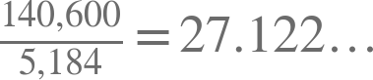

8. Kinetic energy is , for mass in kilograms and speed in meters per second. Find  in joules.
a. 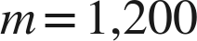, 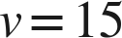
135,000 joules
b. , 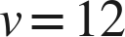
61,200 joules
c. , 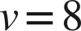
2,240 joules

Working backwards.
9. Find the missing value in each situation.
a. 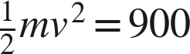 and . Find .
m = 50
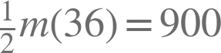, so .
b. 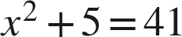, where is positive. Find .
x = 6
c. A square lawn of side feet is turfed at 2.50 dollars a square foot with a flat 40 dollars delivery, and the total is 2,290 dollars. Find .
n = 30
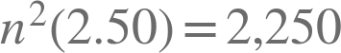, so 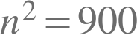.

Reading the situation.
10. Two problems use the numbers 20, 3 and 5. A: a gym charges 20 dollars to join plus 3 dollars for each of 5 classes. B: a gym charges 20 dollars for each of 3 months, plus 5 dollars to join. Find both totals, and explain why the words 'plus' and 'each' do not decide the operation.
A is  dollars. B is  dollars. Both problems contain the same numbers and the same two words, so the words cannot be what decides; what decides is which amount is repeated.
This is the state guide's named misconception, tested directly: circling the numbers and boxing the key words produces identical markings on two problems with different answers.

11. A square yard of side 15 feet is turfed at 4.80 dollars a square foot, with a flat 120 dollars for delivery. Which expression gives the total cost?
○ A. 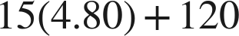
● B. 
○ C. 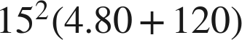
○ D. 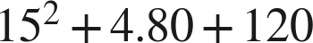
B

12. Select ALL of the expressions whose value is 45 when .
☐ A. 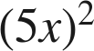
☒ B. 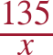
☒ C. 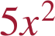
☒ D. 
☐ E. 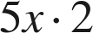
☒ F. 
B, C, D and F

